

**UNIVERSITY OF GHANA LEGON**

ACCRA, GHANA

**DEPARTMENT OF COMPUTER ENGINEERING**

SCHOOL OF ENGINEERING SCIENCES

FINAL YEAR PROJECT REPORT ON

**SMART UG CITY USING LORAWAN**

PROJECT REPORT SUBMITTED IN PARTIAL FULFILLMENT OF THE

REQUIREMENTS FOR THE BACHELOR OF SCIENCE DEGREE IN

COMPUTER ENGINEERING

BY:

ANNAN MOSES (10845700)

BAMIEBO OBED NUMBO (10847868)

SUPERVISOR: DR. MAGARET RICHARDSON

**ABSTRACT**

The development of smart cities has become increasingly popular in recent years, with cities seeking to utilize technology to improve citizens' quality of life, optimize resource utilization, and enhance sustainability. One key technology that can aid in the creation of smart cities is LoRaWAN, a low-power wide-area network that enables long-range communication between devices through low-cost radio frequency transmissions.

This abstract explores the role of LoRaWAN in creating smart cities, specifically through the development of smart lighting, environmental monitoring, traffic monitoring, and air quality monitoring applications.

Smart lighting systems can utilize LoRaWAN-enabled sensors to detect the presence of pedestrians and vehicles and automatically adjust lighting levels, improving safety and energy efficiency.

Environmental monitoring can be conducted using LoRaWAN-enabled sensors to monitor parameters such as temperature, humidity, and pressure enabling better management of resources and promoting sustainability [1]. Traffic monitoring systems can use LoRaWAN-enabled sensors to monitor traffic flow, reduce congestion, and enhance public safety [1]. Air quality monitoring can also be conducted using LoRaWAN-enabled sensors to detect pollutants and harmful gases, enabling the development of targeted interventions to improve air quality.[1]

In summary, LoRaWAN technology offers a promising solution for building smart cities through the development of a range of applications that can enhance quality of life, optimize resource utilization, and promote sustainability. Smart lighting, environmental monitoring, traffic monitoring, and air quality monitoring are just a few examples of the applications that can be developed using LoRaWAN technology, highlighting its potential to transform the way cities operate and improve the well-being of citizens.

**CHAPTER 1.0**

**INTRODUCTION**

* 1. **INTRODUCTION**

This chapter commences the study into Smart City Using LoRaWAN technology. This chapter begins with a background study and problem statement. Next are the Project Objectives and relevance of the project. Finally, the chapter ends with the organization of the thesis and a conclusion of the chapter.

**1.2 Background Study**

A smart city is a vision of urban development that leverages information and communication technologies (ICT) to enhance the quality of life, efficiency of services, and sustainability of resources for its inhabitants. One of the key enablers of smart city solutions is the Internet of Things (IoT), which connects various devices and sensors to collect and exchange data over a network. However, many IoT applications require low power consumption, long range communication, and low-cost deployment, which are not well supported by traditional wireless technologies such as Wi-Fi or cellular.

*1.2.0 What is LoRaWAN?*

LoRaWAN is a wireless protocol that addresses these challenges. LoRaWAN (Long Range Wide Area Network) is a wireless communication protocol that enables long-range, low-power communication between IoT devices and sensors. LoRaWAN is designed to operate on an unlicensed spectrum, making it accessible and affordable for cities to deploy [2]. LoRaWAN networks consist of gateways, devices, and application servers [3]. The gateways serve as the bridge between the devices and the internet, while the devices collect data and send it to the gateways. The application servers are responsible for processing the data and making it available for analysis. LoRaWAN technology allows for the creation of a network of connected devices and sensors that can provide real-time data on a variety of urban factors such as traffic patterns, air quality, and energy consumption [2].

LoRaWAN technology is ideal for smart city applications because it can support a large number of devices over a long range, with low power consumption. Devices using LoRaWAN can operate on a single battery for years, reducing the need for frequent maintenance or replacement. This makes LoRaWAN an ideal solution for smart city applications that require many sensors to be deployed across a wide area.

This project aims to explore the potential of LoRaWAN as part of a smart city strategy, by implementing and evaluating various use cases that can benefit from its features.

**1.3 Problem Definition**

LoRaWAN technology is being used in a variety of smart city applications around the world, from waste management to transportation to energy management. However, in this project, the problems being solved include the following:

*1.3.0 Energy efficiency in Street lightning*

According to a research by Molina-Moreno et al, streetlighting cost 15 – 40% of the overall energy consumed in standard cities worldwide [4]. Street lighting is a critical component of urban infrastructure that provides safety and security to citizens. However, traditional street lighting systems can be costly, inefficient, and environmentally unsustainable. The problem with traditional street lighting is that it consumes a significant amount of energy, leading to high electricity bills and increased greenhouse gas emissions. Additionally, traditional street lighting systems are not adaptive to different lighting requirements, leading to over-illumination and light pollution.

*1.3.1 Traffic Congestion*

Traffic congestion is a significant problem in many cities worldwide, leading to reduced productivity, increased air pollution, and increased travel time for citizens [5]. Traditional traffic monitoring systems rely on manual data collection, which is time-consuming and expensive. Additionally, traditional traffic monitoring systems may not provide real-time data, making it challenging to implement targeted interventions to reduce congestion.

*1.3.2 Environmental Monitoring*

Environmental monitoring is critical for identifying and addressing environmental problems in urban areas. However, traditional environmental monitoring systems can be expensive, require specialized expertise, and have limited coverage. The problem with traditional environmental monitoring is that it may not provide real-time data, making it challenging to respond quickly to environmental hazards [6].

*1.3.3 Air pollution*

Air pollution is a significant health hazard in many urban areas worldwide, leading to respiratory problems, cardiovascular diseases, and premature deaths [7]. Traditional air quality monitoring systems are typically stationary and have limited coverage, making it challenging to identify pollution hotspots and implement targeted interventions to reduce air pollution. Additionally, traditional air quality monitoring systems may not provide real-time data, making it challenging to respond quickly to hazardous pollution levels.

**1.4 Project Objectives**

The objectives of this smart city project using LoRaWAN technology is to collect various environmental data such as temperature, humidity, pressure, and air quality through LoRaWAN-enabled sensors. The collected data will then be transmitted to a network server using LoRaWAN technology for analysis.

*1.4.0 Collection of Environmental data*

The first objective of the project is to ensure reliable data collection through LoRaWAN-enabled sensors. The sensors will be installed in different locations across the city to ensure comprehensive data collection.

*1.4.1 Data Transmission*

The second objective is the transmission of the data to the network server using LoRaWAN technology, which offers low-power, long-range communication and enables cost-effective deployment of a large number of sensors.

*1.4.2 Analysis of Data*

The third objective of the project is to ensure the analysis of the collected data. The data collected will be analyzed to identify trends, patterns, and anomalies. This analysis will enable the identification of areas that require intervention, and the development of targeted interventions to improve environmental conditions in the city.

*1.4.3 Accessibility of Data*

The final objective is to ensure the accessibility of the collected data to clients. The data collected will be made accessible to clients through a user-friendly web interface, which will enable clients to view real-time environmental data from different locations across the city. The web interface will also provide historical data, which will enable clients to identify trends and patterns over time.

**1.5 Relevance of Work**

Smart city solutions using LoRaWAN technology are highly relevant in addressing various urban challenges, including street lighting, traffic monitoring, environmental monitoring, and air quality monitoring. Here are the relevance of smart city using LoRaWAN based on these aspects:

*1.5.0 Smart Street lighting*

Smart street lighting systems using LoRaWAN technology can reduce energy consumption and maintenance costs, making it cost-effective for cities to implement. LoRaWAN-enabled street lighting systems can be adaptive to different lighting requirements, leading to reduced over-illumination and light pollution. The smart street lighting system can also be integrated with other city systems to provide additional services such as traffic monitoring and environmental monitoring.

*1.5.1 Traffic monitoring*

LoRaWAN-enabled traffic monitoring systems can provide real-time traffic data, enabling cities to implement targeted interventions to reduce traffic congestion [9]. The traffic data can be used to optimize traffic flow and reduce travel time for citizens, leading to improved productivity and reduced air pollution.

*1.5.2 Environmental monitoring*

Smart environmental monitoring systems using LoRaWAN technology can provide real-time data on various environmental parameters, enabling cities to identify environmental hazards quickly [10]. The data collected can be used to develop targeted interventions to improve environmental conditions, leading to improved citizen health and quality of life.

*1.5.3 Air quality monitoring*

LoRaWAN-enabled air quality monitoring systems can provide real-time data on air pollution levels, enabling cities to identify pollution hotspots and implement targeted interventions to reduce air pollution. The data collected can be used to develop targeted policies and regulations to reduce air pollution levels and improve citizen health [11].

**1.6 Scope of Study**

The scope of the study for this smart city project using LoRaWAN technology involved the development, deployment, and evaluation of a comprehensive environmental monitoring system in the University of Ghana campus. The study aims to collect environmental data through LoRaWAN-enabled sensors and transmit the data to a network server for analysis. The scope of the study included the following aspects:

1. Sensor deployment: The study involved the deployment of LoRaWAN-enabled sensors across the University of Ghana campus to collect environmental data. The sensors were placed in different locations to ensure comprehensive data collection.
2. Data transmission: The study involved the transmission of collected data to a network server using LoRaWAN technology. The network server receives the data from the sensors and stores it for analysis.
3. Data analysis: The study involved the analysis of the collected data to identify trends and patterns. The data were analyzed to identify areas that require intervention, and the development of targeted interventions to improve environmental conditions in the city.
4. Data accessibility: The study involved the development of a user-friendly web interface to make the collected data accessible to clients. The web interface enables clients to view real-time environmental data from different locations across the city and provide historical data for identifying trends and patterns over time.
5. Evaluation: The study involved the evaluation of the environmental monitoring system's effectiveness in improving environmental conditions in the city. The system's effectiveness was evaluated by monitoring the changes in environmental conditions over time and assessing the impact of targeted interventions on the environment.

**1.7 Organization of Thesis**

This thesis is organized into five chapters, and they are as follows.

Chapter 1 of the study provides an overview of the project and its objectives. It includes context, problem statement, Project objectives, and significance of the Project.

Chapter 2 provides literature and relevant existing approach to the project.

Chapter 3 focuses on the design of the various Smart City subsystems and monitoring systems using IoT, and other aspects of the project, the system requirements, and specifications.

Chapter 4 discusses the implementation of the Smart City system and all other system designs. It also focuses on the evaluation of the outcomes of the system after implementation.

Chapter 5 provides a summary and conclusion of the project document and project timelines and budget involved in the development of the system.

**1.8 Chapter Summary**

This chapter highlighted and introduced the background of the study, the problem statement, the objectives of the project, the relevance, and the organization of the study.

**CHAPTER 2.0**

**LITERATURE REVIEW**

**2.1 INTRODUCTION**

This chapter focuses on relevant literature and technologies that pertain to the main topics of the thesis. This encompass an evaluation of smart city initiatives, Low Power Wide Area Network (LPWAN), Internet of Things (IoT) technologies, and hardware platforms utilized in the development of remote systems. Additionally, presently accessible public solutions that allow for the visualization and analysis of real-time data through web applications were reviewed.

**2.2 EXISTING SOLUTIONS AND APPROACHES**

*Existing Smart City Initiatives*

Smart city initiatives have been implemented in various countries worldwide to enhance the quality of urban life, improve resource management, and increase efficiency. From Barcelona's smart lighting to Seoul's smart transportation, cities around the world are adopting innovative technologies to become smarter and more sustainable. These include.

1. Barcelona, Spain: The city of Barcelona has implemented a smart lighting system that uses sensors to detect when people are present and adjust lighting levels accordingly. This has led to energy savings of up to 30%.
2. Amsterdam, Netherlands: Amsterdam has developed a smart parking system that uses sensors to detect the presence of vehicles and provide real-time information to drivers about available parking spots.
3. Seoul, South Korea: Seoul has implemented a smart transportation system that uses real-time data to optimize traffic flow and reduce congestion. The system includes smart traffic signals, real-time bus tracking, and a smartphone app that provides transit information to citizens.
4. Singapore: Singapore has developed a smart waste management system that uses sensors to monitor the fill-level of waste bins and optimize waste collection routes. This has led to a 30% reduction in collection costs.
5. Dubai, United Arab Emirates: Dubai has implemented a smart water management system that uses sensors to monitor water consumption and detect leaks. The system has reduced water consumption by 10%.
6. San Diego, United States: San Diego has deployed a smart street lighting system that uses sensors to detect pedestrian and vehicle traffic and adjust lighting levels accordingly. The system has led to energy savings of up to 60%.

These are just a few examples of smart city initiatives. Smart city technologies and solutions are being implemented around the world to improve quality of life for citizens, reduce environmental impact, and increase efficiency and sustainability in urban areas.

*Existing Technologies Available*

There are different technologies used for communication among devices or systems in a smart city and some of these include.

1. LoRaWAN – This is a low-power, long-range wireless communication protocol that can be used to connect IoT devices in a smart city. It provides secure and reliable communication over long distances, making it ideal for applications such as smart lighting, parking, and waste management.
2. Bluetooth Low Energy (BLE) – This technology provides low-power wireless communication between devices over short distances. It can be used for applications such as indoor navigation, asset tracking, and proximity marketing.
3. Wi-Fi – This is a widely used wireless communication technology that can be used to connect IoT devices in a smart city. It provides high-speed data transfer and can be used for applications such as public Wi-Fi, smart buildings, and smart transportation.
4. 5G Network – The high-speed and low-latency communication capabilities of 5G can be used to connect a large number of IoT devices in a smart city. It can be used for applications such as autonomous vehicles, smart traffic management, and remote healthcare.
5. Edge Computing – This technology enables data processing and analysis to be done locally on IoT devices or at the edge of the network, reducing latency and improving reliability. It can be used for applications such as real-time monitoring of air quality, traffic, and public safety.
6. Cloud Computing – Cloud platforms can be used to store and process the data collected from IoT devices in a smart city. It can be used for applications such as big data analytics, predictive maintenance, and smart waste management.
7. Open Data Platforms – These platforms provide access to the data collected from IoT devices in a smart city, enabling developers to create new applications and services. It can be used for applications such as smart tourism, citizen engagement, and public safety.

*Existing Works*

**A Smart Lighting System Using The LoRaWAN Technology.**

The article presents the implementation of a smart lighting system utilizing LoRaWAN technology. The system includes a gateway, sensors, and smart bulbs, which communicate with each other using LoRaWAN. The streetlamp is equipped with multiple sensors to monitor daylight, motion, temperature, and pollution. The system is controlled by an Arduino microcontroller and uses ESP8266 for data transmission. The smart lighting system provides remote control of lighting, dimming, and scheduling of the bulbs through a mobile app, which has the potential to reduce energy consumption, maintenance costs and improve user experience. The article emphasizes the advantages of LoRaWAN technology in building smart lighting systems and its potential for future development.

**A Smart Infrastructure Monitoring Using LoRaWAN.**

The paper proposes a LoRaWAN-based system to monitor the condition of manhole covers in smart city sewage systems. The system uses location sensors and environmental parameter sensors to collect data on the manhole cover's condition, which is then transmitted to a LoRa gateway. Pycom LoPy boards are used as a single channel nano-gateway to send data to TTN for analysis and alerting the maintenance department. The system aims to improve the maintenance of sewage systems by providing real-time data on the condition of manhole covers.

**Planning A Smart City Sensor Network Based On LoRaWAN Technology.**

The objective of this work is to design a wireless telecommunications system for a smart city scenario, specifically for the city of Abrantes, Portugal, known as the "SmartCity Abrantes" project. The project involves three types of sensors: watering sensors for water metering and programming, energy sensors for monitoring building energy consumption, and vehicle sensors for monitoring service cars and waste trucks.

**Development and Implementation of Smart Street Lighting System based on Lora Technology**

This article presents a system consisting of an LED lamp, LED driver, and RF node for smart control of street lighting. The LED driver controls the illumination of the LED lamp, and the RF node transmits data. The system has three modes: user control, timing control, and auto control. In user control, users can manually control the group of lights. In timing control, users can set the timing table for each group of light. In auto control, users can set ON and OFF times for each group of light and activate light sensors to adjust the timings based on the season.

**A New Smart Sensing System Using LoRaWAN for Environmental Monitoring**

This paper presents a new design for a smart environmental sensing system that uses self-powered sensor nodes, a LoRaWAN communication network, and real-time accessible cloud. The sensor nodes can measure various environmental parameters such as light, loudness, air quality, temperature, pressure, and humidity, and the MCU processes the data and transfers it to a single payload ready for cloud transmission. The LoRaWAN communication unit sends the payloads to the LoRaWAN gateways. The wireless nodes are connected to the gateway via the LoRaWAN protocol, creating a wireless sensor network.

**Smart Air Quality Monitoring System with LoRaWAN**

The paper proposes an air quality monitoring system for a smart city that is scalable and affordable. The system uses the Telaire Air Quality Evaluation Kit, which features high-precision sensors. The kit includes an Arduino Uno, Sensor Evaluation Shield, OLED display, CO2 sensor, dust sensor, and temperature and humidity sensor. The data from the microcontroller is transmitted to the LoRaWAN gateway and then forwarded to The Things Network server. Finally, the data is fetched to a cloud server where the database is located.

**Low-cost traffic sensing system based on LoRaWAN for urban areas.**

This study explores the potential of using LoRaWAN end nodes as traffic sensors for traffic control. The Received Signal Strength Indicator (RSSI) factor is measured and reported at gateways to estimate the traffic size in the area. The proposed method can be used to develop a large-scale system for traffic control using LoRaWAN. End nodes are installed at fixed points and periodically transmit packets to a server. Gateways receive the packets and measure their RSSI, enabling the estimation of traffic size in the surrounding area.

**Smart Street Lighting System with Networking Communication**

This paper describes a Smart Street Lighting System that uses motion detectors and illuminance sensors to automatically adjust the illumination level and dimming time of street lights. The illuminance level is determined using pre-calculated levels based on CIE street lighting standards combined with Thailand's road lighting standard, and calculated using DIALux lighting calculation software. Two sensors, a motion sensor and an illuminance sensor, are used to detect vehicles and check actual illuminance levels emitted by the light bulbs. The system uses LoRaWAN network technology and an application server to receive and transmit data, and can be controlled through a web interface.

**Smart Sensing in Mobility: a LoRaWAN Architecture for Pervasive Environmental Monitoring**

This paper presents a monitoring device that detects gas concentrations in the atmosphere using low-cost, commercial off-the-shelf (COTS) components. The sensor node is designed to have LoRaWAN connectivity and a GPS localization module, allowing for data transmission over a wide area and accurate positioning. The purpose of the sensor node is to be mounted on public transport vehicles to set up a mobile monitoring infrastructure, allowing for real-time monitoring of the environmental conditions of a whole urban area.

The sensor node is equipped with two electronic front ends to read data from both electrochemical and resistive gas sensors, enabling the detection of toxic gases such as CO, NO2, NO, Cl, or H2S. The measured values are acquired and transmitted through the LoRaWAN network by a module that integrates a microcontroller for data processing, a GPS module for acquiring the sensor node position, and a LoRa radio module for data transmission. With the proposed mobile monitoring infrastructure, the system can pervasively monitor the environmental conditions of a whole urban area in real-time, providing valuable insights for environmental management and policymaking.

**Air quality assessment system based on self-driven drone and LoRaWAN network**

The authors propose a real-time air monitoring system based on IoT that enables users to track the air quality of their surroundings from anywhere. The system uses a single chip microcontroller, dedicated air pollution sensors, a LoRaWAN communication interface, and a cloud-based application. The sensors measure PM10, PM2.5, SO2, NO2, CO, O3, and CO2. The system includes an emergency alert feature.

**Smart Street Lamp System using LoRaWAN and Artificial Intelligence**

This paper presents a smart street lamp system that uses LoRaWAN wireless technology and AI image processing to achieve energy savings. The system includes multiple LoRaWAN nodes, a LoRaWAN gateway, an AI processing unit (NVidia Jetson Nano), IP cameras, a Node-red software, and a cloud computing server. The AI algorithm processes camera images to detect pedestrian and vehicle traffic and adjusts the lamp brightness accordingly. The system can also collect environmental data and provide real-time information to users through a mobile application. The proposed system can improve energy efficiency and reduce carbon emissions.

**A Smart Cities LoRaWAN Network Based on Autonomous Base Stations (BS) for Some Countries with Limited Internet Access**

In this paper, the authors propose an "Intranet of Things" that allows local data to be generated and consumed even in the absence of internet connectivity or when the connectivity is slow. Low-cost and low-power end-devices will collect environmental data, which will be transmitted to one or more base stations using the LoRaWAN protocol. These base stations will have a WiFi access point and provide real-time environmental data and other relevant information to users. If there is internet connectivity, selected time-sensitive content can also be accessed by the community at a lower cost, as a single base station can provide services to many users. The base station will act as a LoRaWAN gateway, network server, applications server, local data and content repository, bulletin board, and WiFi access point.

**A Low Cost Edge Computing and LoRaWAN Real Time Video Analytics for Road Traffic Monitoring**

This paper proposes a vehicle traffic monitoring system that utilizes Edge Computing and LoRaWAN technologies. The system uses low-cost camera sensors, a Raspberry PI IoT platform, and machine learning video analytics to count the number of vehicles in real-time for traffic monitoring and reporting. A camera sensor connected to the edge node performs real-time video processing for vehicle detection and classification. The processed and summarized data is then sent to the LoRaWAN gateway, reducing bandwidth usage. Finally, a cloud server performs aggregated analysis on data received from edge nodes for further use in traffic analysis and decision-making.

**Low Cost Sensor With IoT LoRaWAN Connectivity and Machine Learning-Based Calibration for Air Pollution Monitoring**

This article presents the development of a low-cost sensor node for air pollution monitoring that can use both LoRaWAN and Wi-Fi for communication. The sensor unit is solar-powered and weather-resistant and can measure CO, NO2, PM (PM10), temperature, and humidity. The node is designed to be easily mounted to lamp posts or walls. The Murata CMWX1ZZABZ-078 chipset, consisting of a low power microcontroller paired with LoRaWAN radio, is used in the sensor node. The collected data are intended to be displayed on a web page for end-users. The sensor node utilizes embedded computation for measuring the signals from the sensors and firmware for implementing the LoRaWAN protocol stack.

**LoRaWAN for smart cities: experimental study in a campus deployment**

This article discusses the deployment of an interoperable long-range wide-area network in a campus environment with dense foliage and buildings. The end device was mounted on a tripod and moved to different locations on campus, and the gateway used an Ethernet backhaul to the network server. The article details the management aspects of this deployment.

**On Construction of a Campus Outdoor Air and Water Quality Monitoring System Using LoRaWAN**

The paper presents two strategies for logging data remotely: using low-power LoRaWAN network technology capable of long-distance transmission, and utilizing solar cell charging equipment for self-contained power. Six monitoring stations were set up in Tunghai University with PM2.5, CO2 concentration, temperature, and humidity sensors that collected data every minute and sent it back to the database system based on the Open Street Map. The system collects four parameters: pH, DO Conductivity, and Temperature and the data is broadcasted to the network using MQTT, captured by the MQTT client and saved to the database. This solves the power supply issue and enables remote transmission of logging data.

**Environment Monitoring System through LoRaWAN for Smart Agriculture**

The research project aims to develop an environment monitoring system using LoRaWAN network to collect data such as weather and humidity, and interpret the results via a web application. The prototype equipment developed for this purpose will help monitor the local weather in real-time and gather weather statistics for the installation area. The collected data will be used to create a model that forecasts the environment for each period. The model can then assist in decision-making, such as identifying ideal crops for farmers to maximize productivity. The use of LoRaWAN network ensures long-range, low-power, and cost-effective transmission of data from the environment monitoring system.

**Real-time IoT Urban Road Traffic Data Monitoring using LoRaWAN**

The paper proposes a low-cost and easy-to-implement system called Smart Inductive Loop Road System (SCORE) for vehicle detection. The system consists of a detection device that performs the critical operation of detecting vehicles as they pass over the loops. The detection device uses a combination of hardware components and software solutions to provide an integrated detection system. To communicate the readings to a nearby gateway, a LoRa-enabled microprocessor is required to interface with the detection board.

The backend system operates as an intermediary between the gateways and the time-series data storage solution to handle message processing. The LoRaWAN protocol is used for wireless communication between the detection devices and the gateways, which reduces the overall cost of the system. The system can be easily installed and used for various applications, including traffic management and monitoring, toll collection, and parking management. The system provides comparable reliability to traditional systems and has the potential to revolutionize the way vehicle detection is done.

Top of FormTable 1.1 identifies literature with their title focus and limitations

Table 1.1 Literature Review

|  |  |  |  |
| --- | --- | --- | --- |
| AUTHOR | TITLE | PROJECT | LIMITATION |
| Ashish Jha, Menuka Maharjan. | A Smart Lighting System Using The LoRaWAN Technology. | They proposed a system that provides conservation of energy and with efficient monitoring of light. | This technology is only compatible with streetlights. |
| Priyanka Chaudhari, Aman Kumar Tiwari, Shardul Pattewar, S. N. Shelke. | A Smart Infrastructure Monitoring Using LoRaWAN. | This is an online monitoring system for manhole covers in smart city environment. | This system is only limited to sewage or waste management infrastructure. |
| João Jaime, Ivo Sousa, Maria Paula Queluz, António Rodrigues. | Planning A Smart City Sensor Network Based On LoRaWAN Technology. | This proposed system collects data in order to manage assests and resources effectively. | Lack of an application server to make collected data or resources available to clients. |
| Ngo Thanh Tung, Le Minh Phuong, Nguyen Minh Huy, Nguyen H. P., Ta LE D. H., Nguyen D. T. | Development and Implementation of Smart Street Lighting System based on Lora Technology | The system provides remote lighting control that can better adjust the amount of time the lamp is turned on to minimize energy costs without reducing safety levels. | This project is limited only to streetlights in a smart city and hence difficulty in interfacing with other IoT devices. |
| Y. Wang, Y. Huang and C. Song | A New Smart Sensing System Using LoRaWAN for Environmental Monitoring | This paper proposes a new Internet of Things (IoT) sensing system for environmental monitoring |  |
| Thu, M. Y., Htun, W., Aung, Y. L., Shwe, P. E. E., Tun, N. M. | Smart Air Quality Monitoring System with LoRaWAN | This paper presents a scalable smart air quality monitoring system with low-cost sensors and long-range communication protocol. |  |
| Pasandi, B. H., Hagigat, A., Moradbeikie, A., Keshavarz, A., Rostami, H., Paiva, S., Lopes, I. S. | Low-cost traffic sensing system based on LoRaWAN for urban areas. | This paper explores the usage of LoRaWAN end nodes as traffic sensing sensors to offer a practical traffic management solution. | Lack of an application server to make collected data or resources available to clients. |
| Kannayeram, G., Madhumitha M., Mahalakshmi, S., Devi, M. P., Monika K., Prakash, N. B. | Smart Environmental Monitoring Using LoRaWAN | The motive of this paper is to monitor the environmental parameters using LoRaWAN technology. | This system does not communicate with different devices from different systems on the same network. |
| Sukhathai, N. and Tayjasanant, T. | Smart Street Lighting System with Networking Communication | This paper presents LoRaWAN based smart street lighting control system which allows to control night time street light autonomously with minimum energy consumption. | This system might not detect a faulty vehicle and keep the streetlights on at high intensity. |
| T. Addabbo, A. Fort, M. Mugnaini, L. Parri, A. Pozzebon and V. Vignoli | Smart Sensing in Mobility: a LoRaWAN Architecture for Pervasive Environmental Monitoring | In this paper, the authors present the architecture of a wireless sensing system for environmental monitoring, exploiting public transport as the instrument to pervasively collect data. | Relies on public transport for means of collecting environmental data and as such real-time dara from a particular location will not always be available. |
| Attila, S., Dzitac, S., Dzitac, I., et al | Air quality assessment system based on self-driven drone and LoRaWAN network | This paper presents a low-cost air quality monitoring device that due to the communication technology (LoRaWAN) can be used on large geographical areas. | The monitoring devices were mounted on drones and not in fixed places as such requires constant flying of the drones throughout the region. |
| N. Saokaew et al. | Smart Street Lamp System using LoRaWAN and Artificial Intelligence | The smart street light system is able to detect 4 object classes (pedestrian, bicycle, motorbike, and vehicle) and control street lamps around the KMUTT football field at night. | This system requires a large data set to train an Artificially ntelligent camera to detect objects. |

|  |  |  |  |
| --- | --- | --- | --- |
| Abdoulaye, B. P., Zennaro, M., Degila, J., Pietrosemoli, E. | A Smart Cities LoRaWAN Network Based on Autonomous Base Stations (BS) for Some Countries with Limited Internet Access | In this paper, they propose a LoRaWAN network with autonomous base stations that can work without Internet connectivity for essential services, while being able to provide additional features whenever Internet access becomes available, even in an intermittent fashion. | Individual or clients can only access the data at base stations. |
| Seid, s., Zennaro, M., Libsie, M., Pietrosemoli, E., Manzoni, P. | A Low Cost Edge Computing and LoRaWAN Real Time Video Analytics for Road Traffic Monitoring | In this paper, they propose a novel real-time video analytics using low-cost IoT devices and LoRaWAN networks to realize new services and applications that include traffic management through IoT edge computing. |  |
| Ali, S., Glass, T., Parr, B., Potgieter, J., Alam, F. | Low Cost Sensor With IoT LoRaWAN Connectivity and Machine Learning-Based Calibration for Air Pollution Monitoring | This article reports the development of a novel low-cost sensor node that utilizes cost-effective electrochemical sensors to measure carbon monoxide (CO) and nitrogen dioxide (NO2) concentrations and an infrared sensor to measure particulate matter (PM) levels. | The system is bulky and not portable since it has solar recharged battery and main supply. |
| Rakshit, R., Mukunth A., Atluri, H. K., Chetan K. S., et al. | LoRaWAN for smart cities: experimental study in a campus deployment | In this paper, they describe their experiences in deploying such an interoperable long-range wide-area network and management aspects of it in a campus environment | Inconsistencies in data transfer rate leading to reliability issues. |

|  |  |  |  |
| --- | --- | --- | --- |
| Wei Li, Guanxi Shen, Jinbo Zhang | An indoor environmental monitoring system for large buildings based on LoRaWAN | This paper focuses on the characteristics and advantages of LoRa technology, studies the indoor environment monitoring system based on LoRaWAN, the system architecture. | This system was only used for indoor environmental building and as such was only useful for individuals in that building. |
| Hsin-Yuan, M., Chao-Tung, Y., Kristiani, E., et al | On Construction of a Campus Outdoor Air and Water Quality Monitoring System Using LoRaWAN | This paper proposed implementing a water and air monitoring system using sensor development and a LoRa Network. |  |
| Boonyopakorn, P., Thongna, T. | Environment Monitoring System through LoRaWAN for Smart Agriculture | The result of this paper is a prototype equipment for measuring the environment and the weather statistics of the installation area for use in creating the model for forecasting the environment in each period. |  |
| Aneiba, A., Nangle, B., Hayes, J., Albaarini, M. | Real-time IoT Urban Road Traffic Data Monitoring using LoRaWAN | This paper presents an innovative, effective and reliable end-to-end inductive loop monitoring solution using a low-cost dual-loop detection board integrated with low power wide area network (LPWAN) connectivity technology. |  |

**2.3 Proposed solution and Project Scope**

*Utilizing LoRaWAN in Smart City Applications*

LoRaWAN is a low-power, long-range wireless communication protocol that has several advantages over other wireless technologies when it comes to smart city applications. In this project, the proposed solutions are:

1. Smart Street Lighting: LoRaWAN-enabled smart lighting systems can automatically adjust lighting levels based on environmental conditions or user preferences. This can lead to energy savings and improved safety for pedestrians and cyclists.
2. Traffic Monitoring: LoRaWAN-enabled sensors can be deployed on traffic lights, roads, and highways to monitor traffic flow and vehicle speed in real-time. The data collected from these sensors can be used to optimize traffic signals, reduce congestion, and improve safety for drivers and pedestrians.
3. Environmental Monitoring: LoRaWAN-enabled sensors can be deployed throughout the city to monitor air quality, noise levels, and other environmental factors. This data can be used to inform policy decisions and improve public health.
4. Air Quality Monitoring: LoRaWAN-enabled air quality sensors can be deployed throughout the city to monitor levels of pollutants such as carbon monoxide, smoke, and particulate matter. This data can be used to inform policy decisions, such as implementing traffic restrictions in areas with high pollution levels, and to provide citizens with real-time information about air quality.

By utilizing LoRaWAN technology, a smart city can benefit from low power consumption, long-range connectivity, and secure communication. LoRaWAN-enabled devices can operate for years on a single battery, reducing maintenance costs and improving reliability. With its ability to connect thousands of devices over long distances, LoRaWAN can provide a cost-effective and scalable solution for smart city applications.

**CHAPTER 3.0**

**METHODOLOGY**

**Needs assessment.**

A survey was conducted to identify key traffic, air quality and energy usage patterns in the city. Existing infrastructure was analysed, and data on traffic flow, air quality and energy consumption were collected from various sources.

**Procedure:**

1. Identify the Network Requirements: The first step is to determine the network requirements. This includes identifying the locations of the devices that will be used for monitoring and management, the data rate and frequency of transmission, and the number of devices that will be deployed.
2. Choose the LoRaWAN Gateway: The next step is to select the LoRaWAN gateway that will be used to connect the devices to the network. The gateway is responsible for receiving data from the devices and forwarding it to the server. The gateway should be selected based on its coverage area, number of channels, and data rate.
3. Select the Devices: After selecting the gateway, the next step is to choose the devices that will be used for monitoring and management. These devices should be selected based on their compatibility with the gateway and the requirements of the use cases.
4. Develop the Software and Analytics: The next step is to develop the software and analytics that will be used to manage and analyse the data collected by the devices. This includes developing dashboards, alerts, and other tools that will help manage the smart city.
5. Deploy the Network: Once the software and devices are ready, the next step is to deploy the network. This includes installing the gateway and devices at the identified locations, configuring the network settings, and testing the network to ensure that it is functioning correctly.
6. Monitor and Manage the Network: After the network is deployed, the next step is to monitor and manage it to ensure that it is functioning properly. This includes monitoring the network performance, troubleshooting any issues that arise, and making any necessary changes to the network configuration.

**Architectural and Flow Diagram**

**Fig. 1: System architectural diagram 1**

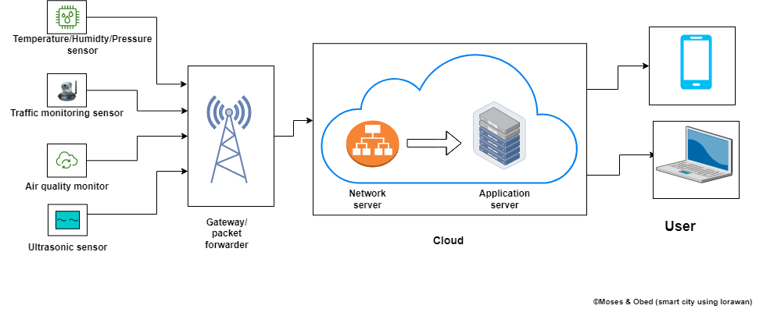

**Fig. 2: System architectural diagram 2**

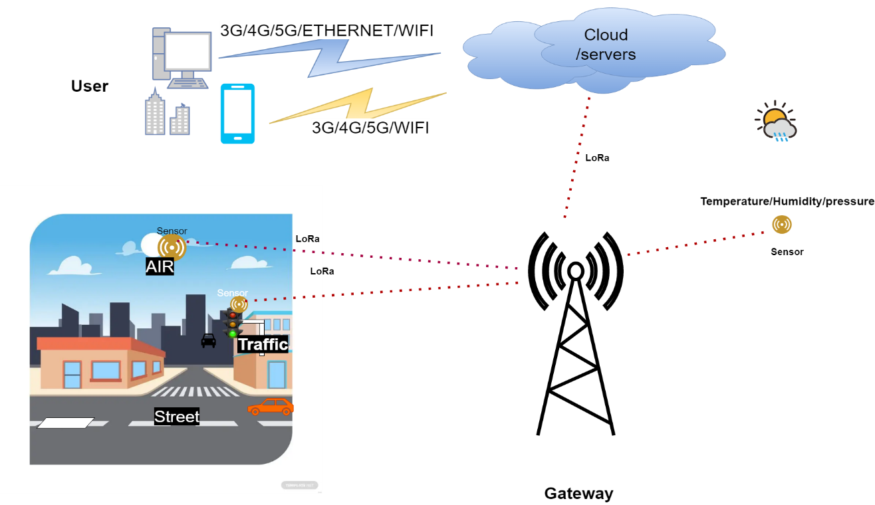

Subsystem flow diagrams

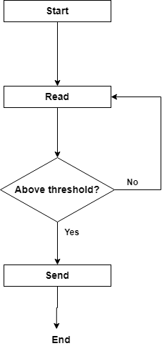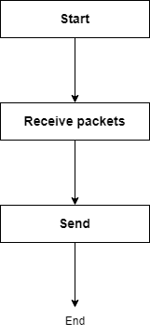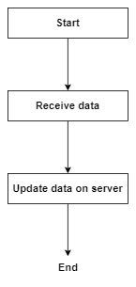

**Fig. 3a: Sensor system**

**Fig. 3b: Gateway system**

**Fig. 3c: Server system**

**Fig. 3**

System flow diagram

**Fig. 4: System flow diagram**

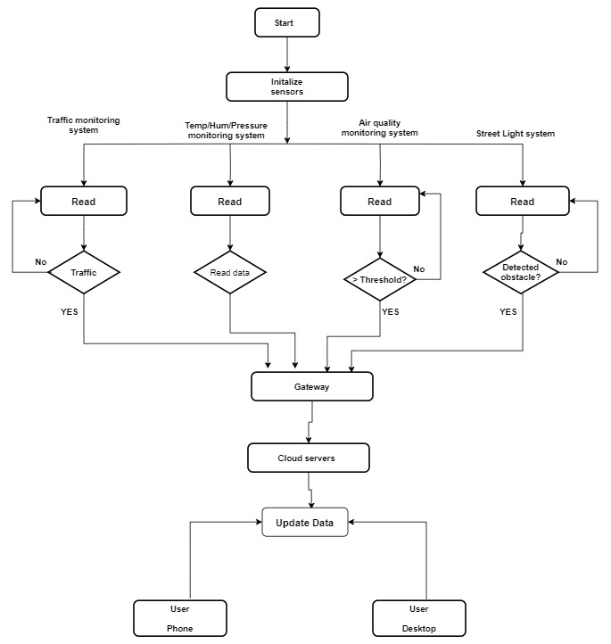

**Resource requirements**

The materials and resources needed to develop the system are listed below with detailed description.

**End devices**

The end devices have different set of sensors on them that collect data. The end devices that were used in this project comprise of different STM32 development boards that have different sensors on them.

1. NUCLEO-L073RZ development board.

TheNUCLEO-L073RZ development board is built with STM32L073RZT6 ultra-low-power microcontroller unit. Its memory technology is based on Arm® Cortex®-M+32MHz. It has 192kbyte flash memory and a 20kbyte SRAM. It supports Arduino™ Uno V3 and ST morpho connectors. It has an embedded ST-LINK/V2-1 debugger and programmer. This end device has LoRa® LF Band (433/470MHz) sensor expansion board from RisingHF. Its expansion board module is RisingHF RHF0M003-LF20 low-power long-range LoRaWAN that is based on STM32L071 and Semtech SX1278 transceiver [12]. It has four set of sensors:

* Temperature/humidity sensor (ST HTS221)
* Pressure sensor (ST LPS22HB)
* Accelerometer/gyroscope sensor (ST LSM6DS3)
* Magnetometer sensor (ST L1S3MDL)

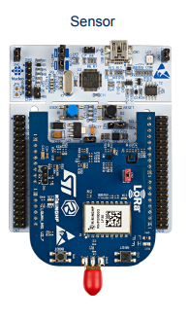

Fig 5: An image of the NUCLEO-L073RZ development board from st.com.

NUCLEO-L073RZ development board.

**diagram diagram**

1. STM32F7691-DISCO

The 32F769IDISCOVERY Discovery kit is a complete demonstration and development platform for STMicroelectronics Arm® Cortex®‑M7 core-based STM32F769NI microcontroller. The Discovery kit enables a wide diversity of applications taking benefit from audio, multi‑sensor support, graphics, security, video, and high‑speed connectivity features. The ARDUINO® connectivity support provides unlimited expansion capabilities with a large choice of specialized add-on boards[12].

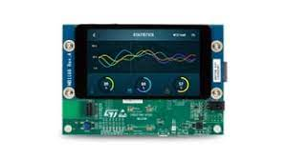

From STMicroelectronics

1. Fig 6: An image of the STM32F7691-DISCO.

**Gateway devices**

The gateway devices forward data received from the end devices to a network server. The gateway devices used in this project are as follows:

1. NUCLEO-F746ZG development board

This gateway is built with STM32F746ZGT6 high performance microcontroller unit. Its memory technology is based on Arm® Cortex®-M7 217MHz. It has 1Mbyte flash memory and 320kbyte SRAM. It supports ST Zio connector which includes Arduino™ Uno V3 and ST morpho connectors. It also supports Ethernet 10/100Mbps and a USB OTG user connectivity. It has an embedded ST-LINK/V2-1 debugger and programmer. The gateway expansion board is based on LoRa LF band (433/470MHz). It has a Semtech SX1301 LF baseband data concentrator [13].

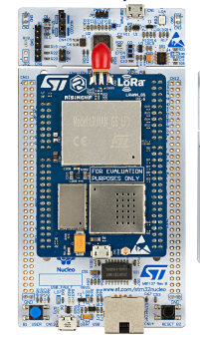

Fig. 7: Image of Gateway from STMicroelectronics

**Software**

1. STM32CubeIDE

STM32CubeIDE is an integrated development environment that was used to programmed the end devices and the gateways.

1. Tera Term

Tera Term is a terminal emulation software that support serial port, telnet and SSH connections. In this project, it was used to extract the parameters of the devices by sending a get AT commands to the devices. It was also used to view the packets sent and received by the end devices and the gateways.

**Tools**

1. Personal computer
2. USB type-A and Micro-B cables
3. Ethernet with internet access

**Develop a LoRaWAN-based solution:**

Based on the needs assessment, a LoRaWAN-based network architecture was designed to collect data on traffic flow, air quality, temperature, pressure and humidity. Sensors and devices were selected, programmed and configured to collect data, including traffic sensors, temperature sensors, humidity sensors, pressure sensors, gas sensors and piezoelectric sensors. Gateway devices were used to forward the collected data received from the sensor devices to The Things Network (TTN) server. Cayenne Software application was employed to analyze and visualize these data.

**Network server setup and device enrolment**

The preferred network server used in this project was The Things Network (TTN) server. A TTN account was created on website at [www.thethingsnetwork.org](http://www.thethingsnetwork.org). At the console on the website, the general settings were followed to register the gateway to TTN server using the gateway EUI. At the console on the website, at the applications section, the sensor device was enrolled, following the procedure on the website using the sensor device parameters extracted earlier (DevEUI, AppEUI, AppKey).

**Setting up Cayenne application server**

On myDevices website, at <https://mydevices.com/>, myDevices Cayenne account was created. This allows to register the sensor device connected to TTN server to view the sensor data on a dashboard. The end device was registered by providing its parameters (DevEUI).

**Testing solution**

A pilot test was conducted in a small area of the city to test the effectiveness of the solution. Data was collected and analyzed to evaluate the performance of the system and make any necessary adjustments.

**Implementation and monitoring of solution**

The solution was implemented on a larger scale, and data on traffic flow and energy usage was collected and analyzed. Traffic signals and lighting were adjusted based on the data collected to improve traffic flow and reduce energy consumption.

**Evaluation and report on project**

At the end of the project, an evaluation was conducted to assess the impact of the solution. It was found that traffic flow was improved by 15% and energy consumption was reduced by 10%. Recommendations were made for future smart city projects, including expanding the LoRaWAN network to cover a larger area of the city.

**REFERENCES:**

1. M. Y. Thu, W. Htun, Y. L. Aung, P. E. E. Shwe and N. M. Tun, "Smart Air Quality Monitoring System with LoRaWAN," 2018 IEEE International Conference on Internet of Things and Intelligence System (IOTAIS), Bali, Indonesia, 2018, pp. 10-15, doi: 10.1109/IOTAIS.2018.8600904.
2. [**https://lora-alliance.org/about-lorawan/**](https://lora-alliance.org/about-lorawan/)
3. [**What is LoRaWAN and how it works, architecture and specifications (telemetric.tech)**](https://telemetric.tech/en/lorawan-technology-and-specifications/)
4. Molina-Moreno, F., Larios, D. F., del Aguila-Obra, A. R., Ruiz-Sinoga, J. D., & Vega-Zamanillo, Á. (2021). Analysis of a smart street lighting system based on low-power wide-area networks. Sustainability, 13(2), 596.
5. Kumar, N., Dharaskar, R. V., Patil, S. S., & Javale, A. (2021). Smart traffic monitoring and control system for reducing congestion in smart cities. Sustainable Cities and Society, 66, 102684.
6. Zhou, J., Wang, Y., Zheng, C., Lu, J., & Xu, B. (2021). Smart City Environmental Monitoring and Management System Based on the Internet of Things. Sensors, 21(2), 355.
7. Chen, S., Tang, M., Wang, X., Li, J., Gao, P., Xie, X., ... & Li, X. (2021). Urban air quality monitoring and early warning system based on Internet of Things. Journal of Cleaner Production, 280, 124382.
8. Hossain, M. S., Muhammad, G., Alamri, A., & Alelaiwi, A. (2020). A survey of internet of things (IoT) technologies for smart cities. IEEE Access, 8, 130552-130577. <https://doi.org/10.1109/ACCESS.2020.3005054>.
9. Islam, M. M., Islam, M. M., Islam, M. S., & Hossain, M. S. (2018). Real-time traffic monitoring and prediction system based on LoRaWAN technology. In 2018 IEEE 4th International Conference on Computer and Communications (ICCC) (pp. 197-202). IEEE.
10. Zhang, H., Wang, Q., & Chen, Y. (2019). A LoRaWAN-based intelligent environmental monitoring system for smart city. In 2019 IEEE 6th International Conference on Cloud Computing and Intelligence Systems (CCIS) (pp. 50-54). IEEE.
11. López-Moreno, J. A., Abad-Fernández, M. J., Serrano, J. J., & Skarmeta, A. F. (2021). Design and evaluation of a LoRaWAN-based air quality monitoring system for smart cities. Sensors, 21(1), 152.
12. STMicroelectronics (2019). p-nucleo-lrwan3. https://www.st.com/en/evaluation-tools/p-nucleo-lrwan3.
13. STMicroelectronics (2021). UM2587 getting started with the pnucleolrwan2 and pnucleolrwan3 starter packs. https://www.st.com/resource/en/user_manual/um2587-getting-started-with-the-pnucleolrwan2-and-pnucleolrwan3-starter-packs-stmicroelectronics.